Menstruation, Incarceration, Gender, and Race: How the United States’ History of Menstrual Injustice Has Threatened the Lives and Rights of Incarcerated People with Periods
Alexa Silverman
Executive Summary:
United States incarceration rates exploded in the 1980s and continue to grow today, a product of the harsher sentencing policies and unforgiving mindset towards criminality from the so-called political “War on Drugs.” Women’s mass incarceration specifically has grown over 700% since 1980. The “Tough on Crime'' framework of the 70s and 80s has devolved into a contemporary myriad of human rights abuses within the prison system, violations that are often gender and race specific. While limited bodily autonomy is an established element of the prison complex, explicit human rights abuses have surfaced in recent years that impose serious -- and avoidable -- mental and physical trauma unto human beings held in carceral spaces. For prisoners with periods, menstruation behind bars is a traumatizing phenomenon that strips inmates of their human dignity. With scattered and insufficient product regulations across the country, prisoners with periods have been forced to ration, layer, create their own, and submit to administrative abuse in order to obtain the necessary period products. The results of sub-standard menstrual equity policy have threatened the mental, physical, and emotional health of some of the most vulnerable populations in the United States. As Black people comprise the demographic majority of those incarcerated, menstrual injustice behind bars is the newest in a long line of actively racist criminal justice constructs. Further, gender-specific healthcare for incarcerated Americans has long put childcare in the social and legislative forefront of women’s rights behind bars. It is only in the 21st century that incarcerated menstrual equity has made its way into the public spotlight, despite the same carceral issues of repressed agency being relevant for almost 200 years. American policy makers across state, local, and federal governments need to implement comprehensive, constructive, and consistent menstrual health policy for incarcerated women so that both immediate relief can be provided to those menstruating while incarcerated and so that equitable menstrual justice can finally be a national priority.

What is the Issue?
Background
United States mass incarceration and the harsh social framework of crime and punishment have formed our contemporary criminal justice system, largely in part due to the restrictive, unforgiving criminal drug policies established by Richard Nixon and Ronald Reagan in the 1970s and 80s as part of the politicized “War on Drugs.” Although there are more men in the prison system than women, women’s incarceration has specifically expanded at a rate that greatly outpaces their long-standing minority status over the past 40 years. Of the 1.2 million women under the surveillance of the penal system today, over 200,000 are housed in federal, state, and local prisons. The majority of incarcerated women are held in state facilities and local jails, with only a small percentage in federal prisons. Fig. 1 visually illustrates the immense growth of American women’s mass incarceration and the distribution of women inmates in facilities. Based on averaged prison demographic data, the average female prisoner in the United States is a Black woman in her mid-thirties of a low-income background with a history of trauma. For the majority of modern prison structures, there has been an intense racial divide, for both men and women, in which Black prisoners comprise the majority of facilities nationwide. The cultural impact of racism in the criminal justice system is well established; many books and articles published in the past two decades have posited that the relatively recent phenomenon of mass incarceration is “The New Jim Crow.” The status of menstrual injustice the modern American prison system embraces -- one of highly subjective discretion and unaccountability for abuses -- has had deeply harmful impacts, most felt by Black women (as they comprise the majority of incarcerated women). Similarly to the Jim Crow era political machine in the 19th and 20th centuries, our contemporary mass incarceration complex accepts and upholds bodily violence against and control over Black women. While the outright brutality of Jim Crow criminal “justice” system has arguably dispersed in the past century and a half, denying inmates who are overwhelmingly Black the necessary and safe products for a healthy, trauma-free menstruation cycle is an assault on the bodily integrity of those incarcerated. The physical and mental impacts of inconsistent period resources, of which there are many, are outlined below. While Black women still outnumber White women in prison, in the past few decades we have witnessed growing numbers of White women incarcerated and, conversely, shrinking numbers of Black women. Fig. 2 tracks the slow reversal of women’s race demographics in prison over the 21st century and demonstrates that there is still a large disparity between Black and White women’s imprisonment.

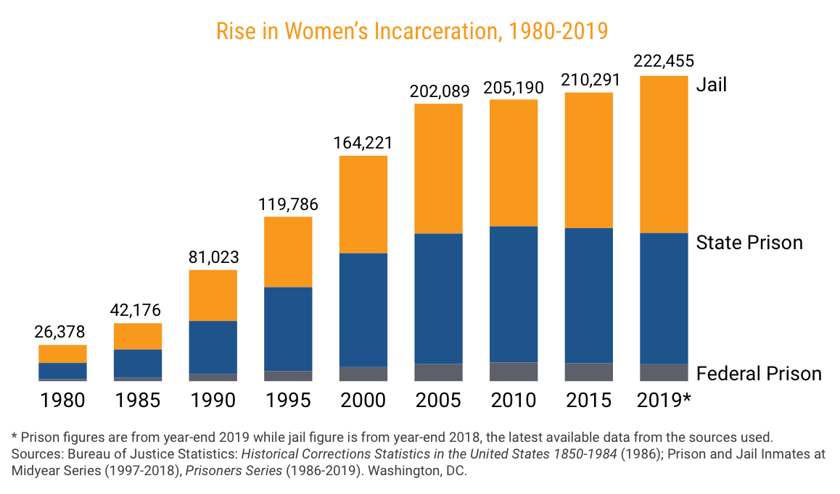
Fig. 1. Multi-tiered bar graph organizing women’s incarceration data from 1980 to 2019. The graph shows that women’s incarceration has multiplied by around 8 in the past 40 years. The data also shows that consistently, incarcerated women have been housed in local jails and state prisons much more so than federal prisons. From “Fact Sheet: Incarcerated Women and Girls,” The Sentencing Project, 2019.

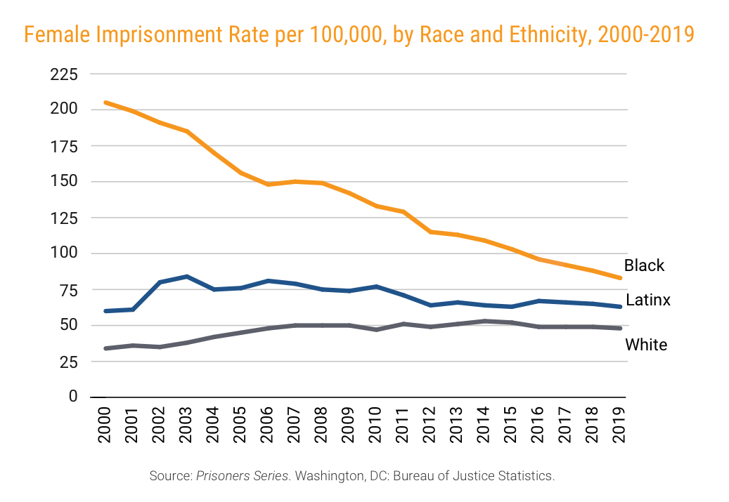
Fig. 2. Line graph showing how Black, Latinx, and White womens’ incarceration has decreased over the past 20 years. The race gap seems to be closing between Black and White women but there is still a higher rate of Black female imprisonment than White. From “Fact Sheet: Incarcerated Women and Girls,” The Sentencing Project, 2019.

Prisoners have a right to healthcare as stated by the Constitution. The 8th and 14th Amendments specifically protect incarcerated individuals from “Cruel and Unusual Punishment” and while human dignity is not explicitly stated in the Constitution, it has come to be recognized by the courts as a fundamental human right, not to be revoked when one is imprisoned. Advocates for just treatment of women behind bars publicly unified in the 1970s, when US incarceration rates expanded exponentially. While there is little documented evidence of incarceration policies and struggles with menstruation through the 1980s and before, women’s bodily oppression in prison has historically been characterized by the legislative and administrative focus in the sphere of pregnancy, childbirth, and child-rearing. While children are in the realm of reproductive rights, a positive legislative priority, the governmental focus for a long period of time was partially an external issue related to child-rearing. Given that women were considered the primary family caretaker, interest in female incarcerated health centered around the wellbeing of their children in (during pregnancy) and beyond the facility. Half of the prison activism pamphlets dated from 1972 to 1999 in an exhibit compiled by Barnard’s Center for Research on Women indicate an acute concern for the development of the children of women prisoners. Other issues surrounding the treatment of incarcerated women have been a maintained focus of prison advocacy groups throughout the last 40 years or so but the majority have been focused on structural gender equality -- in comparable educational, professional, and reimmersion into society programming, for example -- instead of attention to the specific necessary medical needs of incarcerated women and prisoners with periods.

For prisoners with periods, menstruation is a terrifying prospect ripe with human rights abuses. When pads and tampons are not provided in a substantial quantity or length of time, women are forced to wear a product or multiple for exorbitant lengths of time, create makeshift pads and tampons out of materials around them, or risk free bleeding onto their clothes and cell (which is ultimately a violation of dress codes at some prisons). Although additional pads and tampons are available for purchase at prison commissaries, when considering the high percentage of inmates who come from low-income backgrounds and the miniscule wages those incarcerated make during sentences, it is an unrealistic, inhumane expectation for women to buy even a cycle’s worth of products. Further, the experience of inmates having to ask guards or administrators for additional or any products reinforces the prisoner-guard divide, resulting in the heightened perception of dehumanization during a time when a critically human condition is acutely present and unavoidable. There are even numerous reported instances of women being forced to engage in sexual acts with facility guards in exchange for period products. This system of an extreme power imbalance presents intense, damaging physical and psychological health risks: physically, by subjecting the body to unwelcome bacteria growth, and mentally by the prison power structure that forces shame and embarrassment upon those in need of period products who can be denied necessary products arbitrarily. The status of accountability, or lack thereof, is a specific, harmful, and unjust policy blindspot of today’s legislation, and hundreds of thousands of women and prisoners with periods suffer yearly because each facility has the agency and discretion to dictate the provided menstrual products they deem worthy.

Brief Overview of Current Policy
The First Step Act (2018) mandates free pads and tampons with varying sizes for incarcerated women, but this legislation only applies to federal facilities. As there is only a small percentage of women held there, The First Step Act is actively useless to the wider carceral population. State and local prisons are subject to their own individual jurisdiction, which leads to much variety in “policy” and little accountability. As of today, only 13 states have laws mandating adequate period products to prisoners, with varying human rights language in each state’s stipulations. A handful of comprehensive laws have been proposed by Congresspeople in the last four years, but all of them still remain in the introductory phase or in a random committee with no other foreseeable action.

Outside the realm of carceral spaces, a lot of activist and legislative effort has been focused on eliminating the Tampon Tax; 20 states have eliminated additional taxes on menstrual products in the past 30 years. This is an example of menstrual justice in the contemporary legislative spotlight, which gives hope for a focus on broader menstrual equity in American culture.

Why is this Issue Important?
The lack of accessibility to adequate products for all inmates who menstruate is a human rights crisis; it traumatizes those in carceral spaces physically and mentally, and solidifies the weighted, abuse-prone power dynamics between prisoner and guard that America perpetuates. Fortified access to sufficient menstrual products in carceral spaces reinforces the preservation of human dignity, which is also part of the conversation regarding Constitutional Rights but yields wider international importance about prioritized societal interests. Already vulnerable populations should not be suffering further, especially at the subjective and unaccountable hands of individual wardens, prison administrators, and guards. Immigration Detention Centers in the United States are also experiencing these kinds of human rights abuses regarding lack of bodily agency, which endanger those being held; a further extension of the point about already-vulnerable populations being subjected to inhuman cruelty by the American government. With the long history of prisons being overwhelmingly Black -- despite the shifting racial compositions today for women -- contemporary menstrual injustice, particularly in prisons, has become an extension of a culture based paradoxically both on the exploitation and ignorance of Black bodies.

As the movement of Menstrual Equity in general has come into the advocacy spotlight in the 21st century, there has been an increased focus in ensuring that women’s bodily autonomy is preserved behind bars. Reproductive justice in prison, including a reliable, comfortable menstruation experience, safe gynological care, and abortion provision is part of the important effort to preserve human dignity in carceral spaces. Legislation and accountability are the next steps to ensure that Menstrual Equity in the United States -- and its prisons -- be prioritized by those with the power to effect positive change in our cultural framework.

What Should Policymakers Do?
- Comprehensive legislation is needed with language that explicitly states a variety of products (in size and type; so pads, tampons, and pantyliners from regular to extra absorbent) will be provided at no charge to inmates,
  - Thereby taking the burden off the vulnerable to ask guards for products.
  - This will also work to mitigate the impacts of the socioeconomic status gap created when “additional” (every person experiences menstruation differently) products are only available via commissary -- especially when prisoners make incredibly low salaries across the country and find it difficult to afford items at the commissary in general.
- This legislation needs to apply to federal, local, and state facilities with an emphasis on state facilities across the country, as the majority of incarcerated women are housed in these jails.
- There needs to be accountability at all levels to make sure prisoners with periods are receiving the necessary resources to ensure safe and healthy menstruation.
  - Ensuring suitable menstrual products for prisoners with periods is a key step in reversing the divisive cultural thinking developed in the 1970s that incarcerated individuals are merely criminals who deserved to be punished.
  - We need to transform the way that the American prison systems view carceral bodies, into a perspective that preserves and prioritizes human dignity and bodily autonomy.

Sources & Further Reading:
- Period Power: A Manifesto for the Menstrual Movement by Nadya Okamoto
- Periods Gone Public: Taking a Stand for Menstrual Equity by Jennifer Weiss-Wolf
- Women and Crime: A Text/Reader by Stacy L. Mallicoat
- No Mercy Here: Gender, Punishment, and the Making of Jim Crow Modernity by Sarah Haley
- The New Jim Crow: Mass Incarceration in the Age of Colorblindness by Michelle Alexander
- Slavery by Another Name: The Re-Enslavement of Black Americans from the Civil War to World War II by Douglas Blackmon
- The American Civil Liberties Union (aclu.org): The ACLU is a national organization dedicated to ensuring human rights for marginalized populations throughout the country. The rights of the incarcerated is a huge subsect of their aims, and state-specific ACLU websites have a wealth of information about state facilities and lawsuits. Period Equity has partnered with the ACLU to publish some important educational resources regarding menstrual equity and its impact on those who menstruate behind bars.
- Period Equity (periodequity.org): Period Equity is a legal non-profit founded by Jennifer Weiss-Wolf and Laura Strausfeld that has advocated for menstrual equity for all parts of society; their focus is currently on outlawing states’ sales taxes on period products, which are essential to human health.
- The Sentencing Project (sentencingproject.org): The Sentencing Project is 30-year-old non-profit organization with a goal to effect sentencing reforms in the US criminal justice system through research and advocacy. Their information is extremely comprehensive and was a great resource for my research.
- The Prison Policy Initiative (prisonpolicy.org): The Prison Policy Initiative is a non-profit organization that researches the harm of mass incarceration in the United States. They are a great resource for information about the current state of our criminal justice system and the systemic disparities in race, ethnicity, and gender.
- Barnard Center for Research on Women (http://bcrw.barnard.edu/archive/prison.htm): The BCRW’s Women’s Prison Activism exhibition from 2006 features 11 pamphlets and research papers from the 20th century regarding American women’s incarceration and gender equality activism. The exhibit is an informative retrospective on the history of women’s prison equality activism from the last quarter of the 1900s.

