HIST BC 3864 Prof. Dorothy Ko

Spring 2023 Office: 803 Milstein

Tues. 4:10-6 p.m.

FEAST AND FAMINE:

**FOOD AND ENVIRONMENT IN CHINESE HISTORY**

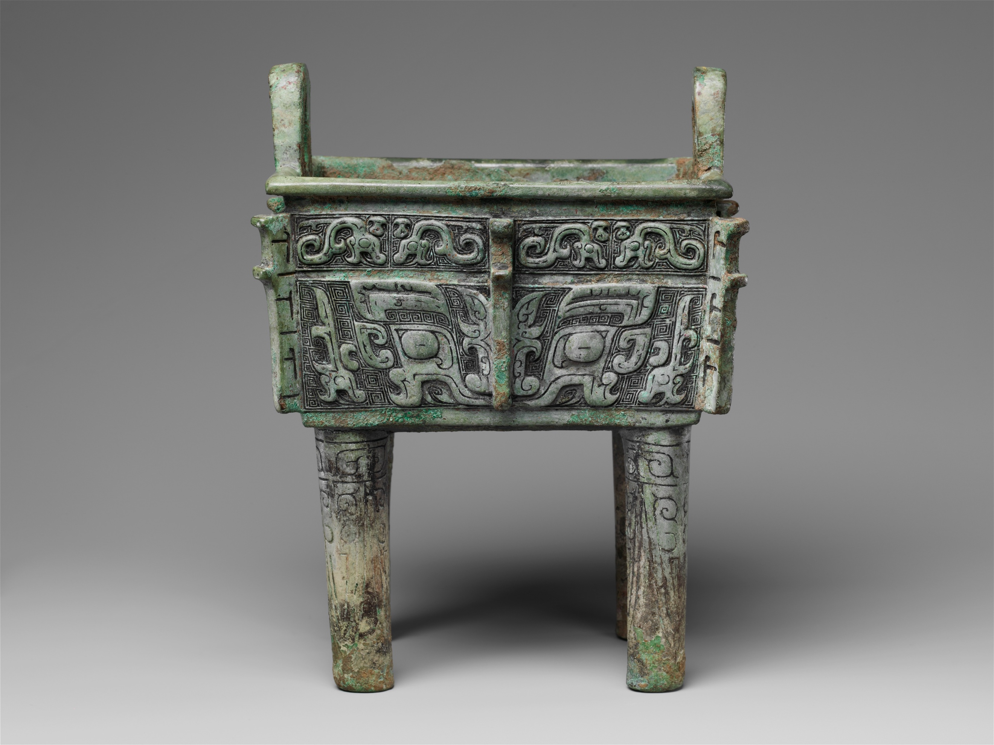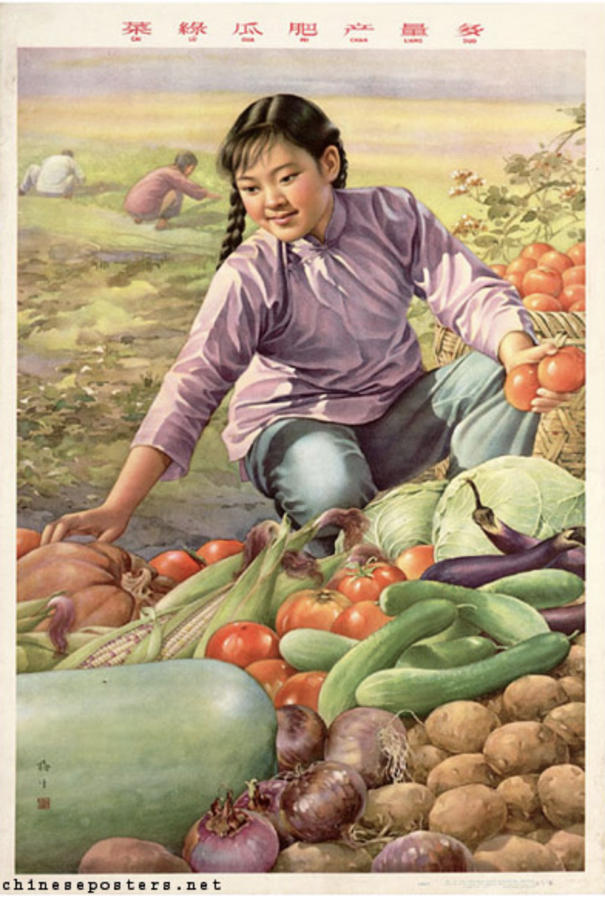

Square cauldron with *taotie* (Glutton mask), PRC propaganda poster, 1959

12th-11th century B.C.E., Metropolitan Museum of Art Chineseposters.net

All food systems involve the co-production between the sun (or artificial light generated by fossil fuel), the earth, water, air, microbes, humans, and animals. Using the Chinese food system as a case study, this seminar has two aims: First, to retrieve the deep ecological connections—the black box—that the neat display on supermarket shelves obfuscates, and second, to examine the centrality of food in the politics, economics, and philosophy of Chinese peoples in a long historical time frame.

Feast (abundance) and famine (extreme scarcity) are anomalies on a systems level; the reality in most years for most people in most regions falls somewhere in between. The provisioning of minimal nourishment to all without discrimination has been the basis of legitimacy for the imperial and modern states in China. Thus on a social level, the axis of feast/famine compels us to explore the relationship between the political economy of food and social inequality. On a personal level, the specter of the two extremes invites the eater to approach the question “what’s for dinner?” as one of food justice and moral choice. These are the salient themes of our course.

Keywords: Food system, food culture, ethnicity, sustainability, health, environment, nature, food security, food justice, industry/agro-industry, capitalism, risks

Prerequisites and Reference Tools:

There are no prerequisites; we welcome students from STEM, history, anthropology, environmental humanities, and other disciplines. Some assigned articles are intended for readers who command rudimentary knowledge of Chinese history, geography, and culture. If you have not taken a Chinese studies course before, you may want to read an excellent textbook (Robert Marks’ *China: Its Environment and History*) in its entirety. You may also want to familiarize yourself with these reference tools:

Timeline of Chinese History and Dynasties:

<http://afe.easia.columbia.edu/timelines/china_timeline.htm>

Historical Maps of China:

<https://www.edmaps.com/html/china.html>

Pronouncing Chinese names in Pinyin:

<https://www.youtube.com/watch?v=iXWjQ984zh4&ab_channel=UnderstandingChineseCharacters&fbclid=IwAR2S9ozvTvQo87MiuQkR2Hho8YmLqM297HYm5a0EN7zk6SoyWSgbi2Mn4N4>

Other useful references:

*The Berkshire Encyclopedia of Sustainability*, v. 1 (the Spirit of Sustainability); v. 2 (the Business of Sustainability):

https://clio.columbia.edu/catalog/11006011

https://clio.columbia.edu/catalog/11006012

Requirements and Grading:

Class Participation (attendance and weekly postings on Canvas—due before class on **Monday @midnight**—including two Summary Postings due on Mar. 7 and May 9): 30%

Short Paper (report of Cooking Lab, about 3-5 pages): 30%

Final Paper (a mini-research paper, about 10-12 pages): 40%

The Cooking Lab is a project in which students, divided into groups of three, would cook one dish from one of the historic recipe books assigned: (1) Hu Sihui’s *Yinshan zhengyao* 飲膳正要 (translated as *A Soup for the Qan* by Buell and Anderson), or (2) Yuan Mei’s *Suiyuan shidan* 隨園食單 (translated as *The Way of Cooking* by Sean Chen). Each student will report their findings and insights in a short paper supplemented by a video and/or photographs/drawings. The report is due **Tues.,** **Mar. 21 @ 12 noon**.

The mini-research paper, due on the day of our scheduled final exam (**Tues., May 9@ 7 p.m.**), involves additional reading, experiments, and/or fieldwork on a topic relevant to the seminar.

Assigned Readings:

The following books can be purchased from Book Culture. They have also been put on reserve at the Barnard Library:

1. Valerie Imbruce, *From Farm to Canal Street: Chinatown’s Alternative Food Network in the Global Marketplace* (Cornell, 2015)

2. Robert B. Marks, *China: Its Environment and History* (Rowman & Littlefield, 2012)

3. Michael Pollan, *The Omnivore’s Dilemma: A Natural History of Four Meals* (Penguin, 2006)

4. YUAN Mei, *The Way of Eating: Yuan Mei’s Manual of Gastronomy*, tr. Sean J.S. Chen (Berkshire, 2019)

The following books are available online:

Valerie Imbruce, *From Farm to Canal Street* [Assigned chapters on Canvas under Required Readings; entire book on Clio]

HU Sihui, *A Soup for the Qan*, Second revised and expanded edition (Brill, 2010). [Canvas course site, under Required Readings. Do not use the first edition published by Taylor & Francis on Clio!]

Robert B. Marks, *China: Its Environment and History* (Rowman & Littlefield, 2012) [Canvas Course site, under eBooks]

Angela Ki Che Leung and Melissa Caldwell, eds., *Moral Foods: The Construction of Nutrition and Health in Modern Asia* (Hawaii, 2019) [Assigned chapters on Canvas under Required Readings; entire book on Canvas under eBooks]

Michael Pollan, *The Omnivore’s Dilemma* [Canvas under Required Readings]

Roel Sterckx, Martina Siebert, and Dagmar Schafer, eds., *Animals through Chinese History: Earliest Times to 1911* (Cambridge, 2019) [Assigned chapters on Canvas under Required Readings; entire book on Canvas under eBooks]

Weekly Schedule:

**I. Introduction**

Jan. 17

WEEK 1: INTRODUCTION

* First seminar meeting; no readings
* Introduction of key themes and course requirements

Jan. 24

WEEK 2: FOOD SYSTEMS: THE INDUSTRIAL FOOD CHAIN AND ITS ALTERNATIVES

* The Industrial food system prevalent in the U.S. today
* Alternative food systems: Organic and Beyond Organic

Required Readings:

Option A:

Michael Pollan, *Omnivore’s Dilemma*, pp. 1-262 (Industrial, Organic, and Beyond Organic)

Option B:

1. Michael Pollan, *Omnivore’s Dilemma*, pp. 1-119 (Industrial); pp. 277-411 (on Foraging, Hunting, and a Perfect Meal)

Jan. 31

WEEK 3: PROVISIONING NEW YORK CHINATOWN

* Immigrant-controlled agribusiness farms
* Ethnicity

Required Reading:

Valerie Imbruce, *From Farm to Canal Street*, pp. 1-72 (Introduction, Ch. 1-3), 154-160 (Conclusion) = Required for all, plus:

Option A:

Ch. 5, “Growing Asian Vegetables in Honduras,” pp. 97-119 [Keywords = agro-industry; contract labor/capitalism]

Option B:

Ch. 6, “Chinese Food in American Culture,” pp. 120-140 [Keywords = ethnicity; food culture]

Feb. 7

WEEK 4: FOOD SYSTEMS: LONG-TERM HISTORICAL PERSPECTIVES

* Factors of stability/sustainability of food systems through long periods of time
* Chinese concepts of “nature,” conservation, and environmental management

Required Readings:

1. Sidney Mintz, “Food at Moderate Speed,” in *Fast Food/Slow Food: the Cultural Economy of the Global Food System*, ed. Richard Wilk et al., pp. 3-11.

2. K.C. Chang, “Introduction,” *Food in Chinese Culture*, ed. Chang, pp. 3-21.

3. Brain Lander et al., “A History of Pigs in China: From Curious Omnivores to Industrial Pork,” *Journal of Asian Studies* (2020): 1-25.

4. E.N. Anderson, “The Development of China’s Sustainability during the Zhou and Han,” in *Food and Environment in Early and Medieval China*, pp. 91-114.

**II. The Chinese Food System: A Deep History**

Feb. 14

WEEK 5: CHINA: ITS ENVIRONMENT AND HISTORY

* Overview of long-term environmental changes in China
* Basic geography and dynastic periods
* Overview of key themes: farming, deforestation, state, war, population, water control, climate change

Required Reading:

Robert Marks, *China: Its Environment and History*, chapter 1 (pp. 1-9); chapter 2 (pp. 10-53); chapter 6 (pp. 223-264); chapter 8 (pp. 331-346).

Suggested Reading:

The rest of the book ☺

Feb. 21

WEEK 6: DOMESTICATION OF PLANTS AND ANIMALS IN EARLY CHINA (Neolithic to Bronze Age)

* Foundations of the Chinese food system
* Ecology and environment
* Close connections between food and thought/philosophy/religion

Required Reading:

1. Francoise Sabban, “The Ideological Foundation of the Food Cultures of Pre-Imperial China,” in *A Companion to Food in the Ancient World*, ed. John Wilkins and Robin Nadeau, pp. 393-402.

2. Roel Sterckx, “Food and Philosophy in Early China,” in *Of Tripod and Palate: Food, Politics, and Religion in Traditional China*, ed. Sterckx, pp. 34-61.

3. Roel Sterckx, “Animal to Edible: The Ritualization of Animals in Early China,” in *Animals through Chinese History*, ed. Sterckx et al., pp. 46-63.

4. Xinyi LIU et al., “From People’s Commune to Household Responsibility: Ethnoarchaeological Perspectives of Millet Production in Prehistoric Northeast China,” *Archaeological Research in Asia* 11 (2017): 51-57.

Feb. 28

WEEK 7: MONGOL-CHINESE COOKING AND ETHNIC IDENTITIES IN THE FOURTEENTH CENTURY

* Reconstructing the “fusion” court cuisine of the Mongol empire
* Connection between food and the construction of ethnic identities

Required Reading:

HU Sihui, *A Soup for the Qan*, tr. Buell and Anderson, **2010 second edition:** Introduction (pp. 3-9); Ch. 1 (pp. 20-22, 28-30, 35-47); Ch. 2 (pp. 102-106, 127-134--starting with "But there is one major exception [latest medical theory]," 146-161); pp. 243-306.

**If you choose to cook from the *Yinshan zhengyao* for your Cooking Lab, read pp. 171-174 before proceeding.

Suggested Readings:

1. Robert Marks, *China: Its Environment and History*, chapters 3-4.

2. Françoise Sabban, “Court Cuisine in Fourteenth-Century Imperial China: Some Culinary Aspects of Hu Sihui’s *Yinshan zhengyao*,” *Food and Foodways* v. 1 (1986): 161-196.

Mar. 7

WEEK 8: YUAN MEI, AN EIGHTEENTH-CENTURY GOURMET

* Gendered knowledge of a gourmet
* Imported exotic ingredients and elite male identities
* Connection between eating and “nourishing life”

Required Reading:

YUAN Mei, *The Way of Eating: Yuan Mei’s Manual of Gastronomy*, tr. Sean J. S. Chen, “Essential Knowledge,” “Objectionables,” and selection of recipes.

**\*\*Mid-term Summary Posting due on Canvas**

[Selected portions of the Chinese original texts and translation, along with the dishes cooked by Chen, are available on Chen’s blog:]

<https://wayoftheeating.wordpress.com/about/>

Suggested Reading:

Robert Marks, *China: Its Environment and History*, chapter 5.

Mar. 21

WEEK 9: BREATHING SPACE (Readings TBA)

**\*\*Cooking Lab Report due @ 12 noon**

Mar. 28

WEEK 10: FOOD AND HEALTH (18th to 20th Centuries)

* Food as medicine in traditional medical thinking
* Modern transformations with the introduction of Western concepts of hygiene and biomedicine in the 19th and 20th centuries

Required Reading:

1. Vivienne Lo, “Chinese Traditional Medicine and Diet,” in *Routledge Handbook of Chinese Medicine*, ed. Vivienne Lo and Michael Stanley-Baker with Dolly Yang, pp. 320-327.

2. Sean Hsiang-lin Lei, “Housewives as Kitchen Pharmacists: Dr. Chuang Shu Chih, Gendered Identity, and Traditional Medicine in East Asia,” in *Gender Health and History in Modern East Asia*, ed. Angela Ki Che Leung and Izumi Nakayama, pp. 166-192.

3. Robert Peckham, “Bad Meat: Food and the Medicine of Modern Hygiene in Colonial Hong Kong,” in *Moral Foods*, ed. Angela Leung and Melissa Caldwell, pp. 173-198.

4. Lawrence Zhang, “Becoming Healthy: Changing Perceptions of Tea’s Effects on the Body,” in *Moral Foods*, ed. Angela Leung and Melissa Caldwell, pp. 201-220.

**III. PRC (1949-present): Food Security; Food Justice**

Apr. 4

WEEK 11: COLLECTIVE AGRICULTURE (1952-1959) AND THE GREAT LEAP FAMINE (1959-1961)

* Brief history of the collectivization of agriculture (Cooperatives to Communes)
* Who/what is to blame for the Great Leap famine?

Required Reading:

1. [For the early history of the PRC, including the First Five-Year Plans, Land Reforms, Collectivization of agriculture, and the People’s Commune movement, view the propaganda posters and the succinct annotations on Chineseposters.net:]

a. First Five-Year Plans, 1953-57 (parts 1-5):

<https://chineseposters.net/themes/first-five-year-plan>

<https://chineseposters.net/themes/first-five-year-plan-2>

<https://chineseposters.net/themes/first-five-year-plan-3>

<https://chineseposters.net/themes/first-five-year-plan-4>

<https://chineseposters.net/themes/first-five-year-plan-5>

b. Land Reform and Collectivization, 1950-53:

<https://chineseposters.net/themes/land-reform>

c. Great Leap Forward, 1958-61:

<https://chineseposters.net/themes/great-leap-forward>

d. Mao’s “Eight-Point Charter of Agriculture”:

<https://chineseposters.net/themes/eight-point-charter-agriculture>

2. Robert Marks, *China: Its Environment and History*, pp. 165-167 (“Waste, Sustainability, and Nutrient Cycles;”) 265-276 (“Socialist Industrialization and Subduing Nature;”) 297-298 (“Wildlife, Consumption, and Epidermic Disease.”)

3. Felix Wemheuer, “Dealing with Responsibility for the Great Leap Famine in the People’s Republic of China,” *The China Quarterly*, no. 201 (March 2010): 176-194.

4. Sigrid Schmalzer, “China’s Great Leap Famine: Malthus, Marx, Mao and Material Scarcity,” in *Scarcity in the Modern World: History, Politics, Society, and Sustainability*, ed. John Brewer et al., pp. 173-191.

Apr. 11

WEEK 12: MARKET REFORMS AND THE URBAN-RURAL GAP (1980s-1990s)

* A new food system under Deng Xiaoping’s Market reforms and implications on people’s health and diet
* Industrial food system in China--how does it compare with that in the U.S. (cf. Week 2)?

Required Reading:

1. [For the history of “Four Modernizations” or “Reform-and-Opening-Up,” view:]

<https://chineseposters.net/themes/special-economic-zones>

2. Jun JING, “Introduction: Food, Children and Social Change in Contemporary China,” in *Feeding China’s Little Emperors*, pp. 1-26.

3. Maris Boyd Gillette, “Islamic Food and Children’s Diet in Xi’an,” in *Cultural Politics of Food and Eating*, ed. James L. Watson and Melissa Caldwell, pp. 106-120.

4. Mindi Schneider and Shefali Sharma, “China’s Pork Miracle: Agribusiness and Development in China’s Pork Industry,” Institute for Agriculture and Trade Policy paper, Feb. 2014, pp. 1-36.

5. Thomas DuBois, “Milk from the Butterfly Spring: State and Enterprise in the Yunnan Dairy Industry, *Rural China* v. 17, no. 1 (2020): 87-110.

Suggested Readings:

1. James L. Watson, “China’s Big Mac Attacks,” *Foreign Affairs* v. 79, no. 3 (2000): 120-134.

2. Mindi Schneider, “Feeding China’s Pigs: Implications for the Environment, China’s Smallholder Farmers and Food Security,” Institute for Agriculture and Trade Policy paper, May 2011.

3. Megan Tracy, “Pasteurizing China’s Grasslands and Sealing in *Terroir*, *American Anthropologist* v. 115, no. 3 (2013): 437-451.

4. Thomas DuBois and Alisha Gao, “Big Meat: The Rise and Impact of Mega-Farming in China’s Beef, Sheep, and Dairy Industries,” *The Asia-Pacific Journal* v. 15, no. 17-1 (2017): 1-20.

Apr. 18

WEEK 13: FOOD SAFETY AND ALTERNATIVE FOOD SYSTEMS IN POST-SOCIALIST CHINA (1990s-2021)

* Key concepts of food safety: social risk, transparency, and trust
* Alternative food systems in China--how do they compare with those in the U.S. (cf. Week 2)?

Required Reading:

1. Yunxiang Yan, “Food Safety and Social Risks in Contemporary China,” *Journal of Asian Studies* v. 71, no. 3 (2012): 705-729.

2. Caroline Merrifield, “Seeing and Knowing: Sourcing Safe Food in Zhejiang,” *Journal of Current Chinese Affairs*, v. 48, no. 3 (2020): 281-300.

3. Yan SHI et al., “Safe Food, Green Food, Good Food: Chinese Community Supported Agriculture and the Rising Middle Class,” *International Journal of Agricultural Sustainability* v. 9, no. 4 (2011): 551-558.

4. Sigrid Schmalzer, “Epilogue,” in *Red Revolution, Green Revolution*, pp. 207-227 (on the New Rural Reconstruction movement and model villages in post-socialist China).

5. Jakob Klein, “Buddhist Vegetarian Restaurants and the Changing Meanings of Meat in Urban China,” *Ethnos* v. 82, no. 2 (April 2017): 252-276.

Suggested Readings:

On nostalgia for a rural utopia:

1. Wen Tiejun, “Four Stories in One: Environmental Protection and Rural Reconstruction in China,” *positions* v. 16, no. 3 (2008): 491-505 (Wen is an outspoken agricultural activist)

2. The blogs of Li Ziqi, holder of Guinness World Record with 14.1 million YouTube subscribers:

<https://www.youtube.com/channel/UCoC47do520os_4DBMEFGg4A>

Apr. 25

WEEK 14: SUMMARY AND PRESENTATIONS

**\*\*Tuesday, May 9@7 p.m. Final Paper and Final Summary Posting due**